ADT Alert Best Practices for Provider Organizations

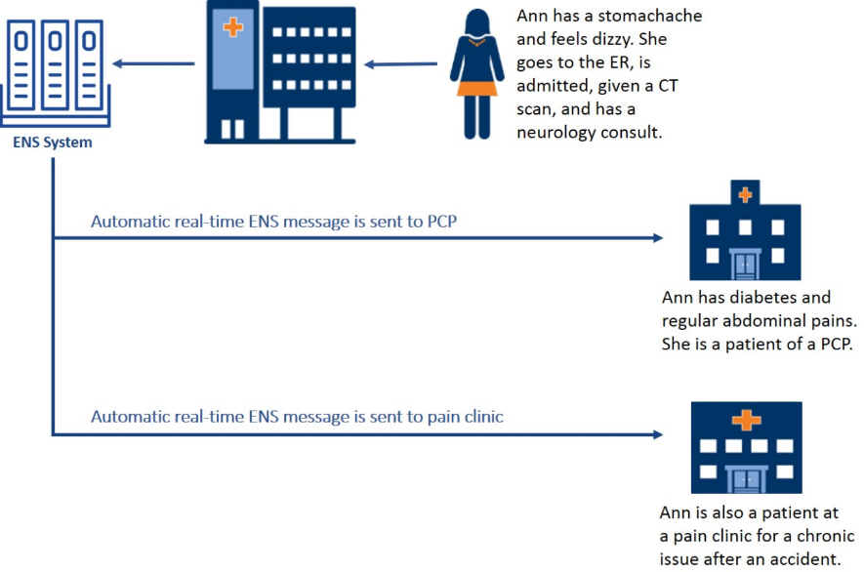

**Table of Contents**

|  |  |  |
| --- | --- | --- |
|  |  | Page Number |
| I. | ADT Alert Background Information | 3-7 |
| II. | ADT Alert Best Practices | 8-14 |
|  | * Understanding your Organization’s ENS Alert   Current State and Selecting a Primary Feed | 9-11 |
|  | * Optimizing ADT Alert Feeds | 12 |
|  | * Using Historical ADT Data to Inform Operations | 13-14 |
| III. | Glossary | 15-16 |
|  |  |  |
| IV. | Provider Organization ENS Alert Inventory Template | 17 |
| V. | ADT Feed Customization Worksheet | 18-19 |

# ADT Alert Background Information

**What are ADT Alerts?**

Admission, Discharge, and Transfer Alerts or ADT Alerts are alerts sent to care providers about their patients’ admissions, discharges, and transfers to and from emergency departments, hospitals, and post-acute care facilities.

ADT Alert notifications include patient demographic information and event details like event type, facility, date and time. These alerts can contain clinical information like reason for visit and diagnosis.



**Where do ADT Alerts Come From?**

ADT Alerts are the end product of an Event Notification Service (ENS). ENS is a specific form of Health Information Exchange (HIE) that occurs after ADT Events.

An ENS system automates the ADT alert distribution to efficiently and securely send patient information to care providers. ENS vendors develop and manage these ENS systems and offer providers the ability to subscribe to these services.

**What is the Massachusetts Statewide ENS Framework?**

To enable utilization of ENS across the state, EOHHS and the Mass HIway developed the Statewide ENS Framework to create an interoperable ENS network.

Certified ENS Vendors have been certified by EOHHS and the Mass HIway to meet specific functional, data security, data sharing and business criteria. These vendors have interconnected their ENS systems to serve all care providers in Massachusetts.

This means that care providers in the Commonwealth can subscribe to a single interoperable, certified ENS vendor to receive ADT alerts from all Massachusetts Acute Care Hospitals and other contributing care facilities, to coordinate care after ADT events.

**How can my organization subscribe to a Certified ENS Vendor?**

There are currently two Massachusetts Certified ENS Vendors, Bamboo Health and Collective Medical Technologies. You can reach out directly to the vendors to see which vendor’s services best meet your organization’s needs.

|  |  |  |
| --- | --- | --- |
| **Certified ENS Vendor** | **Bamboo Health** | **Collective Medical Technologies** |
| Website | [bamboohealth.com](https://bamboohealth.com/) | [collectivemedical.com](https://www.collectivemedical.com/) |
| Contact | Bamboo Health Business Development | Customer Support |
| Telephone | 603-833-8231 | 801-285-0770 |
| Email | [growthopportunities@bamboohealth.com](mailto:growthopportunities@bamboohealth.com) | [support@collectivemedical.com](mailto:support@collectivemedical.com) |

**What are CMS Conditions of Participation (CoP) Notifications?**

As of spring 2021, CMS-9115-F requires hospitals, including psychiatric hospitals and Critical Access Hospitals (CAH), to send ADTs to another healthcare facility, community provider, or practitioner. The goal of these alerts is to improve care coordination by allowing receiving providers/healthcare facilities to deliver timely follow-up care after a patient event.

These ADT alerts are sent to the patient identified provider via Direct message, regardless of whether they are subscribed to an ENS vendor or not. Provider organizations have little to no control over how these ADT alerts are received and rely on patients to identify their correct primary provider which often results in alerts not being sent or being sent to the wrong provider. This makes it difficult for a provider organization to solely rely on CoP notifications as their source of truth for information on their patients’ events.

The CMS Rule requires that a minimum set of data be included in CoP Notifications. ENS Vendors may include more information, but CMS only requires patient name, treating practitioner name, and sending institution name, to be included in the notifications.

**What are some common barriers faced by provider organizations using ADT Alerts in their hospital follow-up workflows?**

To better understand the Massachusetts ADT landscape, in winter of 2023, the Mass HIway fielded a survey to Federally Qualified Health Centers (FQHCs) in the state to better understand the barriers experienced by provider organizations receiving ADT alerts. Some of the common barriers include:

* Limited group of patients included in their ADT feed (e.g. ACO patients only)
* Juggling multiple ADT feeds within the same organization
* Staffing capacity limitations prevent organizations from following up on all ADTs received
* Clinical information, like diagnosis, is not consistently available in ADT alerts which makes triaging ADT alerts difficult. As of the end of 2023, hospitals are including diagnosis information in approximately 55% of discharge ADT messages.
* Currently, only one of the Certified ENS Vendors includes Chief Complaint in Admit messages. As of the end of 2023, hospitals are including Chief Complaint information in approximately 41% of Admit messages based on data from the one Certified ENS Vendor that processes this information.

The Mass HIway has compiled the ADT Alert Best Practices in this document to help provider organizations address some of these common barriers and make the most of their ADT feeds.

**Want to Learn More?** More information on ADT Alerts, ENS and the Massachusetts Statewide ENS Framework is available on the Mass HIway Website [here](https://www.masshiway.net/Services/Statewide_ENS_Framework). You can also watch a recording of the *ADT Alerts: Understanding the Massachusetts ENS Landscape and Making the Most of ADT Alerts* webinar [here](https://masshiway.net/News/On_Demand_Webinars/Massachusetts_ENS_Landscape).

# ADT Alert Best Practices

# **Understanding your Organization’s ENS Alert Current State and Selecting a Primary Feed**

Taking inventory of the different ENS Alerts that are coming into your organization is a helpful first step in understanding what your current state is and what improvements may need to be made.

**Step 1:** Inventory the ENS Alerts that are currently coming into your organization

* What types of alerts are you already receiving? *Please see the “Types of ENS Alerts You May Already be Receiving” table on page 10 for examples of common ENS Alerts*
* What is the source of these alerts?
* Which patients are included in these alerts?
* Where and how are these alerts coming into your organization?

You can leverage the *ENS Alert Inventory Template* to help get you started.

**Step 2:** Identify a “Primary Feed”

* Review your ENS Alert inventory with appropriate stakeholders (HIM, IT, IS, Care Management, etc.)
* Consider if you have a feed that meets organizational needs or is close to meeting organizational needs. Examples of things to consider include:
  + *Which ENS Alert feed best represents the patients you need to be tracking?*
  + *Which ENS Alert feed can most easily be used by staff following up with patients?*
  + *Do we need to establish a new feed to meet our needs or can one of our existing feeds be modified?*
* Select a primary feed based on your ENS Alert Inventory review that can be relied on as your ADT Monitoring feed.
  + Make note of any enhancements that may need to be made to this feed to make it more inclusive of the patients you want to be tracking and/or more user friendly for staff.
  + **Note**: Other ENS Alerts may contain helpful information that can be referenced in tandem to the primary feed, however, the prompt to follow-up with patients can be based on your primary feed.

**Types of ENS Alerts You May Already be Receiving**

|  |  |  |  |  |
| --- | --- | --- | --- | --- |
| Type of Notification | Type of Messages | Method of Receipt | Patients Included | Things to Consider |
| **ADT Feeds**  (Subscribed) | ADT Alerts | Certified ENS Vendor Portal, Direct message in EHR, Population Health Management Tool | Dependent on patient roster being sent to certified ENS Vendor (ACO patients, high risk patients, etc.) | Does your organization have more than 1 ADT feed based on different patient rosters? |
| **CMS Conditions of Participation Messages**  (Unsolicited) | ADT Alerts | Direct message in EHR | Patients who identify their PCP during their hospital or ED encounter | These alerts will go directly to the provider named at the point of care (therefore not all inclusive) |
| **Directly from Hospital**  (Organization specific) | ADT Alerts, ED and Discharge Reports | Fax, EHR, or portal login | Most likely will only receive from hospitals that your organization has an existing relationship with, and for patients who identify their PCP during their encounter. | These reports will contain all pertinent clinical information, including medication information and discharge instructions |

**A Note about CMS Condition of Participation (CoP) Notifications:** CoP notifications are unsolicited ADT alerts sent via Direct message into the EHR. Provider Organizations have little control over how these are received and notifications generally go directly to the patient’s PCP. If you have an ENS Vendor subscription, these CoP notifications are often duplicative and can clog up a provider’s Direct messaging inbox. Providers can unsubscribe from CoP notifications if they feel confident that these ADT alerts are already being received via an ENS Vendor subscription.

For more information on CMS CoP Notifications, see page 7.

# **Optimizing ADT Alert Feeds**

If you subscribe to a Certified ENS Vendor, there are many customizations that can be made to optimize your ADT feed so that it meets your organizational needs. Below are some areas to consider when customizing. You can work with your Certified ENS Vendor to make these customizations.

You can leverage the *ADT Feed Customization Worksheet* to help get you started.

# **Using Historical ADT Data to Inform Operations**

Certified ENS Vendor Subscriptions give organizations access to historical ADT data through a library of submitted ADTs. Analyzing this data can help provider organizations understand trends in their patient population’s emergency department and hospital utilization so that they can better anticipate the needs of their patients.

For example, scheduling and operational adjustments can be made based on utilization patterns to meet patient needs and reduce unnecessary emergency department and hospital utilization.

This type of analysis can be done in many ways, depending on your organizational goals and patient population. Below is an example of an analysis process:

**Sample ADT Utilization Analysis Process**

**Step 1:** Select a time-range of at least one week and pull ADT utilization data from several points in the year for the selected time-range. Getting data from different seasons of the year will help your analysis be more comprehensive and help you understand how different seasons may impact utilization.

**Step 2:** Identify when patients are utilizing the emergency department the most *during* your business hours.

* *Operational considerations:* Do you have enough same day appointments available during this time-frame?

**Step 3:** Identify the day of the week that tends to have the most/least hospital discharges.

* *Operational considerations:* Can blocking of appointments for discharge follow-up be adjusted to anticipate this?

**Step 4:** Identify common reasons for patients unnecessarily utilizing the emergency department.

* *Operational considerations:* Do your patients know this is something they can be seen by your providers for? Do your patients know that you have a clinical advice line and/or walk-in clinic hours available? A patient education campaign may be needed based on these findings.

**Step 5:** From the results of your analysis, identify an operations or workflow change you would like to try.

**Step 6:** Pilot the identified operations/workflow change. To monitor the success of your pilot, you can track its impact on your pilot group through ADT data. Since ADT data is available in real-time, you will have real-time feedback on your pilot’s success and be able to make adjustments as needed.

**Step 7:** Scale your pilot once successful.

# **Glossary**

* **ADT Alert:** Admission, Discharge, and Transfer Alerts or ADT Alerts are alerts sent to care providers about their patients’ admissions, discharges, and transfers to and from emergency departments, hospitals, and post-acute care facilities.
* **CoP Notification:** CMS Conditions of Participation (CoP) Notifications. As of spring 2021, CMS-9115-F requires hospitals, including psychiatric hospitals and Critical Access Hospitals (CAH), to send ADTs to another healthcare facility, community provider, or practitioner. These ADT alerts are sent to providers via Direct message, regardless of whether they are subscribed to an ENS vendor or not. Provider organizations have little control over how these ADT alerts are received.
* **Direct message:** A way to safely and securely exchange health information between healthcare entities. Providers can send and receive health information via Direct Messaging to obtain the medical history and coordinate the care of their patients. This provides a safer way of sharing patient information than faxing or mailing data to other providers.
* **EHR:** Electronic Health Record
* **EOHHS:** Executive Office of Health and Human Services
* **ENS:** Event Notification Service (ENS). ENS is a specific form of Health Information Exchange (HIE) that occurs after ADT Events. An ENS system automates the ADT alert distribution to efficiently and securely send patient information to care providers.
  + **ENS Vendor:** ENS vendors develop and manage ENS systems and offer services to providers through subscriptions
  + **Certified ENS Vendor:** Certified ENS Vendors have been certified by the Mass HIway to meet specific functional, data security, data sharing and business criteria. These vendors have interconnected their ENS systems to serve all care providers in Massachusetts.
* **HIE:** Health Information Exchange
* **PCP:** Primary Care Provider
* **Population Health Management Tool:** A software that can store and aggregate patient data for analysis. These often contain information about patient demographics, utilization and quality measure performance at the patient population level.

# **Provider Organization ENS Alert Inventory Template**

List all types of notifications about patient admission, discharge and transfer events that your organization is currently receiving in the “Type of Notification” column. Then, fill in the subsequent columns with information about each of the notification sources. Consider notifications you are receiving from ENS Vendors, ACOs, directly from hospitals, etc. You can reference the “Types of ENS Alerts You May Already be Receiving” table on page 11 to help you begin your inventory.

|  |  |  |  |  |
| --- | --- | --- | --- | --- |
| **Type of Notification** | **Type of Messages** | **Method of Receipt** | **Patients Included** | **Things to Consider/Missing Elements** |
| Example Row:  *ACO ADT Feed* | *ADT Alerts* | *Population Health Tool* | *MassHealth ACO Patients* | * *Does not include non-ACO patients* * *Staff would prefer to receive alerts in EHR* |
|  |  |  |  |  |
|  |  |  |  |  |
|  |  |  |  |  |
|  |  |  |  |  |

# **ADT Feed Customization Worksheet**

This worksheet will help you think through the set-up of your ADT feed, so that you can ensure it meets your organizational priorities. You can work with your Certified ENS Vendor to make these customizations to your ADT feed.

|  |  |
| --- | --- |
| **Who** | Who from your patient population do you want to be monitoring for admission, discharge and transfer events? *(Chronic disease patients, ACO patients, all active patients?)* |
| **What** | What types of ADT Alerts do you want to be notified about? *(Admit alerts, discharge alerts, transfer alerts, all ADT alerts?)* |
| **Where** | Where do you want staff to receive and review ADT alerts? *(Login to an ENS vendor portal, population health tool, via Direct message in the EHR?)* |
| **When** | When and how frequently do you want staff to be notified about your patients’ ADTs? *(Real-time, daily report, weekly report?)* |